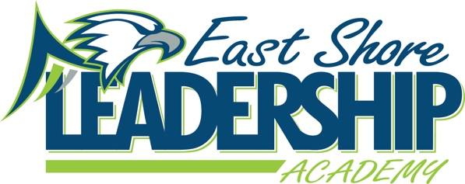
Mission
“East Shore Leadership Academy, in pursuit of excellence, will develop future leaders through a
strong academic foundation and the development of high moral character.”
School Improvement Notes
March 22, 2023
2:00-2:45
Attendance:
Danielle Spradlin Michelle Gardner Nancy Gardner Megan Noel
Samantha Schmaltz Marie Martin Amy Hamilton-absent

Agenda:
- WIG - WIG
  - The Median Growth Percentile on NWEA MAP in Reading and Math will be about average or higher.
- School Improvement Goals
  - 65% of students will meet NWEA Growth Goals in Math by June 19, 2027
  - 65% of students will meet NWEA growth Goals in Reading by June 19, 2027
- Data
  - Teachers are preparing students for M-Step testing
- Student Check-in
  - Specials
    - Music
    - Instruments/Pianos
  - Cafeteria
    - Yogurt Bar
    - Variety in Lunch Menu
      - Meals being repeated
    - Pizza
      - Being able to purchase a second slice of pizza
    - Strawberry Milk
    - Silent Lunch being applied to the whole
  - School Store
    - Snacks
      - Chips
      - Fizzy Water
      - Candy
  - Field Day
    - Student voice in activities selected.
  - Middle School
    - Lockers
- Parent Check-in
  - Rock Star Program
    - Parent appreciates the Rock Star program and the activities planned
  - My Perspectives
    - Feels the curriculum is rigorous and helps to prepare students for high school
- 31a/Title 1 Check-In
  - Title Meeting
    - Title busy meeting with students and teachers
- Reading Check-In
  - Book Vending Machine
    - 3-5 25 passed iReady Reading Lessons
- Math Check-In
  - iReady Curriculum
    - Encouraging mini-lessons to teach standards for units that teachers may not get to
- Leader in Me
  - Classes are working on leadership projects for Leadership Day
- Student Behavior
  - Behavior Intervention
    - Staff member hired
    - Plans being reviewed for end of school year
    - Beginning to plan for next school year
- Student Wellness Group
  - Try it Tuesday
    - May 23rd
    - Students who try snack will receive a sticker
  - Move It Monday
    - School wide brain break to encourage movement
  - Wellness Signs
    - Posted outside and inside of cafeteria
  - Wellness Plan
    - Student Wellness group will review school Wellness Plan
- ESSER III/LEA Plan (ARP) of Use
  - Non-fiction resources for Library
  - Discussed several ideas for remaining funds
  - Athletic Factory
  - Signs for playground
    - Garden under surveillance
- Wellness Plan
  - Team reviewed plan and made updates
- 98c
  - Discussed several ideas for remaining funds

Submitted by: Danielle Spradlin – SIT Chairperson

