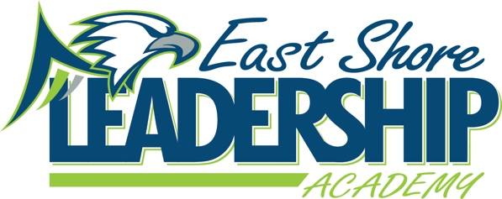
Mission
“East Shore Leadership Academy, in pursuit of excellence, will develop future leaders through a
strong academic foundation and the development of high moral character.”
School Improvement Notes
November 16, 2022
2:00-2:45
Attendance:
Danielle Spradlin Nancy Gardner Michelle Gardner Sandy Johnson
Megan Noel Sammy Schmaltz Coby Marzolf

Agenda:
- WIG - WIG
  - The Median Growth Percentile on NWEA MAP in Reading and Math will be about average or higher.
- School Improvement Goals
  - 65% of students will meet NWEA Growth Goals in Math by June 19, 2027
  - 65% of students will meet NWEA growth Goals in Reading by June 19, 2027
- Data
  - Testing has been completed
  - Data is being used for small group instruction
- Student Check-in
  - Spirit Week
    - PJ Day
    - Crazy Christmas Sweaters
    - Tye Dye Day
    - Dress Like A Staff Member
    - Wacky Wednesday
    - Class Color
  - Christmas Craft Rotation
    - No mixing of grades
  - Specials
    - Music
  - Sport Teams
    - Looking for connections to help students join
- Parent Check-in
  - Veterans Assembly
    - Appreciated the assembly
  - Athletic Factory
    - Choosing one activity to allow for student preference
- Title 1 Check-In
  - Completing Documentation
- Reading Check-In
  - Book Vending Machine
    - Books have been approved waiting for arrival
  - Intervention
    - Groups have been determined
- Math Check-In
  - Math Recovery
    - Working on completing training and assessments
  - iReady Math
    - meeting with teachers to assist with curriculum
- The Leader in Me
  - SLT will model and observe leadership expectations in the cafeteria during K-2 lunch (the week of 12/12) in hopes of increasing the number of Golden Sporks earned by the little leaders & will also pass out rewards for the littles that showcase exemplary behaviors.
  - SLT will ask for K-8 volunteers to participate in a “School of Choice” Pep Rally Dance for School of Choice Week. (To be held in January) Swag bags may be available to those that wish to participate. Posters and word of mouth will be used to HYPE up the event. Mrs. Grossi shared it on her Classroom Facebook page and Google Classroom.
- Student Behavior
  - Parent Conferences
    - Assisting with discussions
  - Behaviors
    - Leveling out
  - Behavior Plans
    - Plans are in place for those that needed
    - Some students are in observation phase to create one
- Student Wellness Group
  - Creating a Healthy Message
    - To be read on announcements
  - Try it Tuesday
    - Unique or fun food sample for students to try in the cafeteria
  - Move it Monday
  - Parent Group
    - Creating group for the school to home connection
- ESSER III/LEA Plan (ARP) of Use
  - Plan was approved by board at October meeting
- 98c
  - Federal money to be used for improvement of instruction
Submitted by: Danielle Spradlin – SIT Chairperson

