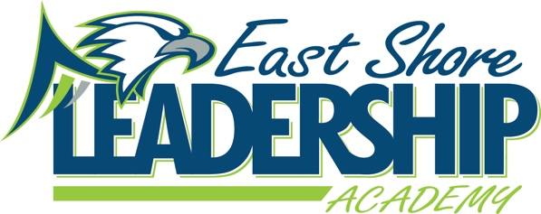
Mission
“East Shore Leadership Academy, in pursuit of excellence, will develop future leaders through a
strong academic foundation and the development of high moral character.”
School Improvement Notes
October 19, 2022
2:00-2:45
Attendance:
Danielle Spradlin Deanna Hall Sandy Johnson Nancy Gardner
Michelle Gardner Samantha Schmaltz Marie Martin

Agenda:
- WIG - WIG
  - The Median Growth Percentile on NWEA MAP in Reading and Math will be about average or higher.
- School Improvement Goals
  - 65% of students will meet NWEA Growth Goals in Math by June 19, 2027
  - 65% of students will meet NWEA growth Goals in Reading by June 19, 2027
- Data
  - iReady Reading & Math
    - Completed
  - NWEA completed
    - Waiting for NMU reports
    - Hall is working on setting student growth goals
- Student Check-in
  - TLIM t-shirt colors
    - Turquoise
    - Green
    - Tie Die
    - East Shore Green
    - Mint Green
    - Lilac
    - Fire engine red
  - Student Activity Ideas
    - Christmas/Holiday Party in Gym
    - Holiday Craft rotation
    - Thanksgiving Feast
    - Tigers Game
    - Spirt Week
    - Lunch Ideas
      - Salad Bar
      - Different food selection
- Parent Check-in
  - Math Night
    - Big hit
    - Liked choices of activities & hands on activities
  - Buddy Bench
    - Providing caps
- Title 1 Check-In
  - Beginning of Year Assessments
    - Still collecting data to determine ranking
- Reading Check-In
  - Orton-Gillingham Assessments
    - Reading Intervention staff helped to administer and/or grade OG beginning of the year assessments
    - Data from the assessments will be shared at mentor meetings to determine starting points for instruction for grades 3-8
  - Magnetic Reading
    - Spradlin has been popping into classrooms to observe implementation of program and to provide feedback to help with the bumps
- Math Check-In
  - Math Night
    - Successful
    - 61 attendees
  - iReady Math
    - Helping to navigate the bumps through discussions and feedback
- Leader in Me
  - SLT discussed and practiced “Meet and Greet” expectations for greeting Board Members and/or other V.I.P.s into the building.
  - SLT discussed “looking the part” of the Lighthouse Team by dressing in school uniform not only “daily” but especially during VIP visits, Board meetings and/or Assemblies.
  - SLT will come up with ideas for our next “Family Engagement Activity February “Cheap Charlie’s 7-Habits Family Pizza Party Certificate
  - Leadership Roles assigned for all SLHT members
- Behavior
  - Behavior:
    - Student behaviors have leveled out; we are working with students who have a Behavior Intervention Plan and their teachers to create the best learning environment.
  - Staff/Parent Engagement Team
    - Math Night was successful.
    - The second meeting happened on 10/18/22 to debrief Math Night and plan for future events.
- Student Wellness Group
  - Meeting for the first time 10/21/22
- ESSER III/LEA Plan (ARP) of Use
  - Board approved minor changes at last meeting
  - Waiting on several items to be approved still

Submitted by: Danielle Spradlin – SIT Chairperson

