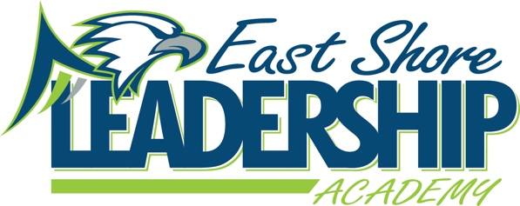
Mission
“East Shore Leadership Academy, in pursuit of excellence, will develop future leaders through a
strong academic foundation and the development of high moral character.”
School Improvement Agenda
January 5, 2023
2:00-2:45
Attendance:
Meeting canceled due to Snow Day

Agenda:
- WIG - WIG
  - The Median Growth Percentile on NWEA MAP in Reading and Math will be about average or higher.
- School Improvement Goals
  - 65% of students will meet NWEA Growth Goals in Math by June 19, 2027
  - 65% of students will meet NWEA growth Goals in Reading by June 19, 2027
- Data
- Student Check-in
- Parent Check-in
- Title 1 Check-In
- Reading Check-In
- Math Check-In
- Leader in Me
- Student Behavior
- Student Wellness Group
- ESSER III/LEA Plan (ARP) of Use
- 98c

Submitted by: Danielle Spradlin – SIT Chairperson

