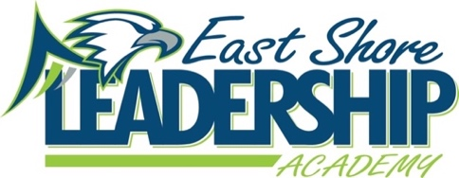
Parent/Guardian Sign-Off Agreement 2020-21
Instructions to Parent and/or Guardians: Please sign and return this page to the Main Office after reading and discussing it with your child, the Student Handbook, Code of Student Conduct, and ESLA School Safety Preparedness Plan (https://www.eastshoreleaders.com).
- Student Handbook https://www.eastshoreleaders.com
- Code of Student Conduct https://www.eastshoreleaders.com
- ESLA School Safety Preparedness Plan https://www.eastshoreleaders.com
- CDC Handwashing Video https://www.youtube.com/watch?v=eZw4Ga3jg3E
- CDC How to Wear a Mask https://www.cdc.gov/coronavirus/2019-ncov/prevent-getting-sick/how-to-wear-cloth-face-coverings.html
Name of Student__________________________________________________________
Student Grade: ___________________________________________________________
As the parent/guardian of__________________________________________________, I have read and discussed the Student Handbook, Code of Student Conduct and ESLA School Safety Preparedness Plan, Handwashing video and How to Wear a Mask, with my child.
I also acknowledge that ESLA in-person students will be participating with ESLA virtual students via teacher’s computer. This may include live recorded video sessions used for educational lessons.
Parent/Guardian Signature: _________________________________________________
Date: ___________________________________________________________________
Parent/Guardian Signature: _________________________________________________
Date: ___________________________________________________________________
Student Signature: ________________________________________________________
Date: ___________________________________________________________________

